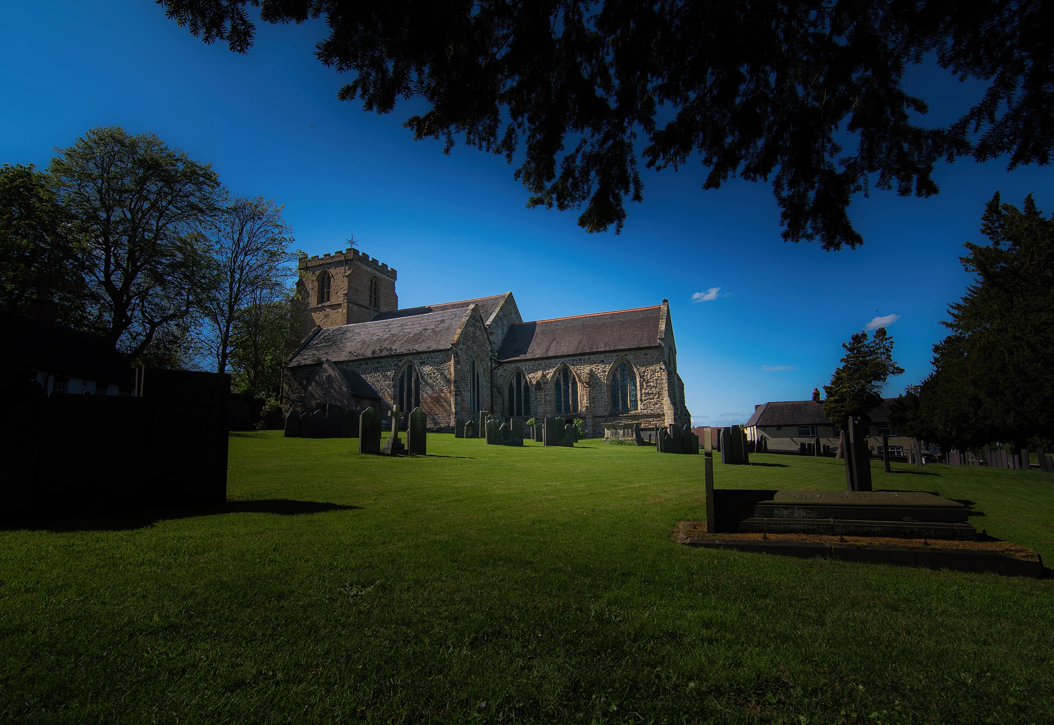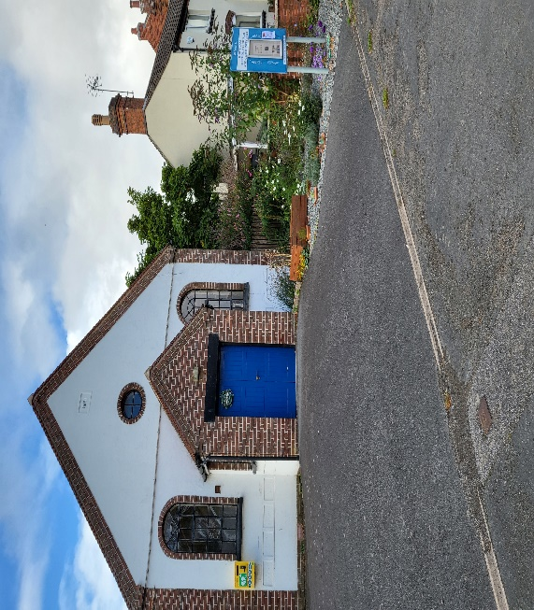

MANCETTER PARISH COUNCIL WOULD LIKE TO GIVE THE OPPORTUNITY FOR LOCAL PEOPLE TO **FIND OUT WHAT IS GOING ON IN OUR AREA** AND TO SHARE IDEAS AND WORK TOGETHER TO BUILD A STRONG COMMUNITY IN THE VILLAGES OF MANCETTER AND RIDGE LANE.

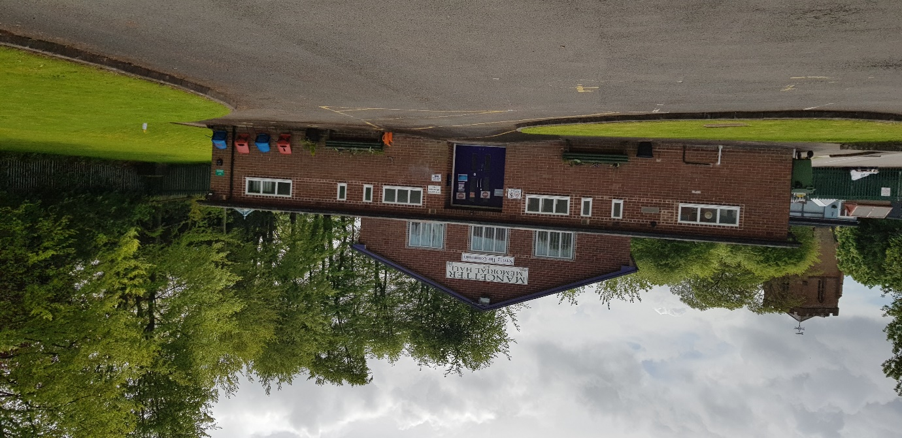

PLEASE JOIN US AT **7PM** ON **WEDS 22ND SEPTEMBER 2021** AT **MANCETTER MEMORIAL HALL.**

LIGHT REFRESHMENTS WILL BE AVAILABLE PROVIDED BY THE LOCAL GIRL GUIDES.